Problems on heap
- K-th Largest element in an array - TUF+
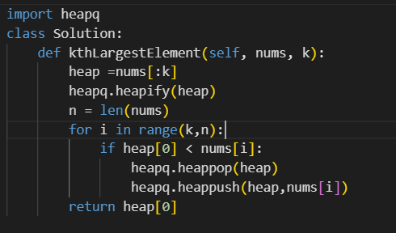
Heapq.heapify takes O(K) time , and it mutates list in-place , and it returns None
TC :
O(n log k)
Breakdown:
- nums[:k] slice → O(k)
- heapq.heapify(heap) → O(k)
- Loop runs n - k times, each iteration does at most a pop + push, each O(log k) → O((n-k) log k)
Total: O(k + (n-k) log k) = O(n log k)
Space: O(k) for the heap.
heapreplace pops the smallest element and pushes the new one — but as one sift operation, not two separate ones. That's the whole point: it's cheaper than heappop() + heappush() back to back.

What it actually does
python
def heapreplace(heap, item):
returnitem = heap[0] # smallest element, save it
heap[0] = item # put new item at the root directly
_siftup(heap, 0) # restore heap property from the root down
return returnitem
Compare that to doing it manually:
python
heapq.heappop(heap) # removes root, moves LAST element to root, sifts DOWN
heapq.heappush(heap, x) # adds x at the END, sifts UP from the bottom

Why it's faster
heappop + heappush does two full sift passes:
- heappop — moves the last element to the root, then sifts it down to restore order
- heappush — puts the new item at the end (bottom), then sifts it up to restore order
heapreplace does it in one sift pass:
- Puts the new item straight at the root, then does a single _siftup from the root
You skip the "move last element to root, sift down" step entirely, and you skip a separate "sift up from the bottom" pass. It's roughly half the work — one O(log k) sift instead of two.

Gut-check analogy
Think of the heap array as a small pile of index cards on a table, root card on top.
- pop+push: take the top card off, grab whatever card was at the very bottom of the pile and slap it on top (probably wrong spot), reshuffle it downward into place — then separately drop your new card in at the bottom and reshuffle it upward into place. Two reshuffles.
- heapreplace: just swap your new card directly for the top card, and do one reshuffle to walk it down to where it belongs. One reshuffle.
heapreplace returns the item that was popped — i.e. the old smallest element (the one that was at heap[0] before the call), not the item you just pushed in.
2)Kth Smallest Element in an Array - TUF+
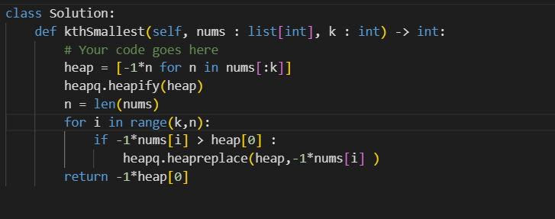

Same as largest , so we will multiply all numbers with -1 , to convert them to negative , so k th largest element will be kth smallest element

3) Sort K sorted array - Tutorial
We are given a k sorted array , in such a way that each element is present at max k distance from its original position in the sorted array , so in a sorted array the index of element can go from i -k to i + k .
HOW DO I APPROACH 👍
I will think in a reverse way , instead of thinking where the element goes , I will think at this index i , which range of elements can be candidates .
So for 0th index , elements from 0 to k are possible ,
If we take min among them , and if we put it on the 0th place , we get the first element of the array . Then for the 1th index , the 0th element is done , so we have to look in range 1 to k +1 , take the min element and put it at the 1st index .
So for ith index the candidate is from ith index to i + k index .
WHENEVER WE WANT TO FIND min/max IN AN ARRAY OF length K , we will think of HEAP solution .
So we will maintain an heap of length k + 1 and choose the smallest element each time as candidate for the ith index , and pop it and add the k+2 th element after popping , repeat this until we get the resultant array .
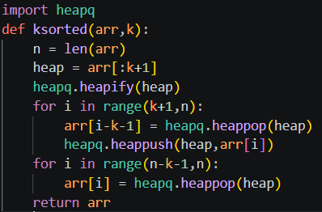
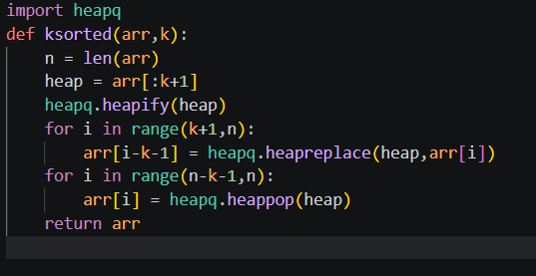
tc : klog(k) + (n-k)logk = nlogk
Sc = k
4) Merge k Sorted Lists - LeetCode
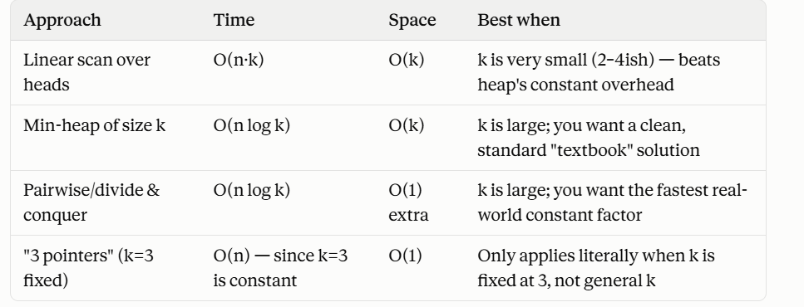
When we have to merge lists which are sorted and we have to get single sorted listed we think of pointer approach , but it works when we know k number , but when we dont have it , we have to think of alternate approach , if we keep heads in a list and pick smallest element each time , it will take n*k time .
AGAIN , IF YOU OBSERVE , WE HAVE TO PICK min element FROM K no of ELEMENTS , so we will think of HEAP approach , where we will pick the smallest element from k and keep it as head and put this next element into heap and continue the process .
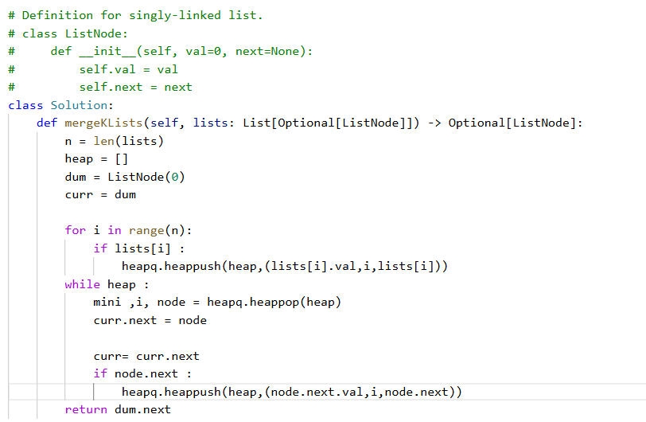
You need to be careful here
Traps in this question 👍
Here's a condensed notes version — trap, why it happens, fix, one-line example.

Merge K Sorted Lists — Heap Traps Checklist
1. Can't push raw ListNode into heap
- Why: heap compares elements to order them; ListNode has no __lt__
- Fix: wrap in a tuple with the value first
- Example: heapq.heappush(heap, (node.val, node)) → still breaks on ties (see #2)
2. Duplicate values crash the comparison
- Why: tuples compare left-to-right; if first elements tie, Python compares the next element — which is the node itself
- Fix: insert a unique tie-breaker as the 2nd tuple element
- Example: (1, nodeA) vs (1, nodeB) → TypeError. Fix: (1, 0, nodeA) vs (1, 1, nodeB) → compares 0 < 1, never touches the nodes
3. Tie-breaker must actually be unique — don't reuse the value
- Why: (node.val, node.val, node) still ties when values are equal, falls through to comparing nodes again
- Fix: use something guaranteed distinct — list index or insertion counter
- Example: (node.val, i, node) where i is that list's fixed index
4. id(node) works but is unnecessary
- Why: object id is unique for its lifetime, so it's a valid tie-breaker
- Fix: prefer list index — simpler, deterministic, no need to think about object lifetime
- Example: (node.val, id(node), node) works but (node.val, i, node) is cleaner
5. Forgetting to push the popped node's .next
- Why: this is the mechanism that advances each list — skip it and you only ever see each list's first node
- Fix: after popping, push the next node from that same list (if it exists)
- Example: pop (1, 0, nodeA) → if nodeA.next: heappush(heap, (nodeA.next.val, 0, nodeA.next))
6. Pushing all N nodes upfront instead of just K heads
- Why: works, but heap size balloons to N, giving O(N log N) instead of O(N log K)
- Fix: only ever keep one node per list in the heap at a time
- Example: init heap with just lists[0], lists[1], ..., lists[k-1] (their current heads), not every node in every list
7. Not checking for None before pushing
- Why: some entries in lists can themselves be None (empty list); accessing .val on None throws
- Fix: guard with if lists[i]: before pushing
- Example: lists = [None, 1→3, None, 2→4] → if lists[i]: heappush(...)
8. lists itself being []
- Why: seems like an edge case but actually needs no special handling
- Fix: the init loop and the while heap: loop both just don't execute
- Example: lists = [] → returns dummy.next which is None, correctly
9. Creating new ListNodes instead of reusing existing ones
- Why: unnecessary allocation, wastes memory/time
- Fix: relink the existing node directly
- Example: curr.next = node; curr = curr.next — not curr.next = ListNode(node.val)

One-line summary pattern to memorize
heapq.heappush(heap, (node.val, i, node)) # value, unique tiebreaker, node

Final complexity
- Time: O(N log K) — N total nodes, each does one pop + one push, heap size capped at K
- Space: O(K) — heap never holds more than one node per list

